SUBMARINERS ASSOCIATION - GOSPORT BRANCH
COMMITTEE MEMBERS
POSITION | NAME | ADDRESS | TEL. & E-MAIL | PHOTO LINKS
CHAIRMAN | Les Catlin BEM | 7 Cyprus Road, Fareham, PO144JY | 01489 886807  les.catlin@sky.com | 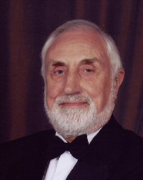
VICE CHAIRMAN | Jim 'Fez' Parker |  | fez.parker@hotmail.co.uk
Hon SECRETARY | Ron Gordon | 31 North Hill, Fareham PO16 7HS | 01329 239498 ronmgordon@ntlworld.com
Hon. TREASURER | Andy Norris
Membership Secretary | Roger Killen | 5 Varos Close,  Gosport PO12 4UL | roger.killen@virginmedia.com
SOCIAL SECRETARY | Paul Mitchell
WELFARE OFFICER | Rob Williams |  | 02392 350120  Rob30Williams@gmail.com
Committee Member 1  (Regalia Secretary) | Martin Zak
Committee Member 2 | Stan Butler
Committee Member 3 | Richard Figgins
Committee Member 4  (Widows Liaison Officer) | Pat McGrath
Committee Member 5 | Bill Williams
Committee Member 6 | Jim Fisher
Ex Officio  STANDARD BEARER | Pending
Stand-by Standard Bearers | Bud Abbott  Jim Fisher

